Math 10

Lesson 2-4 Factoring special polynomials

# Lesson Objectives:

a) Although factoring by decomposition will always work, some trinomials are easier to factor than others.

# Special polynomials

## When a = 1

Although the decomposition method works to factor many polynomials, there are some polynomials that are easier to work with. For example, many of you have probably noticed that when *a* = 1 for trinomials of the form *a*x2 + *b*x + *c*, the two factors of *c* that add up to *b* can be written immediately as two binomials. For example, consider x2 – 7x + 12. The two factors of 12 that add up to –7 are –3 and –4. Therefore we can write the factors as:

x2 – 7x + 12 = (x – 3)(x – 4)

**Question 1**

If possible, factor each trinomial.

a) x2 + 2x – 8 b) a2 + 7a – 18 c) –30 + 7m + m2

## Difference of Squares

Consider something like x2 – 25. The expression is a binomial and the first term is a perfect square, the last term is a perfect square and the operation between the terms is subtraction – hence a **difference of squares**. To factor it we write the terms “in squared form.” The factors are the positive and negative values of the second term.

x2 – 25 = x2 – 52

=(x – 5)(x + 5)

Note, it must be a difference of squares, not an addition of squares.

**Question 2**

If possible, factor each binomial.

a) x2 – 9 b) 16a2 – 25c2 c) 7g3h2 – 28g5

**Question 3**

Show why it is not possible to factor m2 + 16.

## Perfect Square Trinomials

A perfect square trinomial is of the form (*a*x)2 + 2*ab*x + *b*2 or (*a*x) 2 – 2*ab*x + *b*2. The first term is a perfect square, the last term is a perfect square, and the middle term is twice the product of the square root of the first term and the square root of the last term. For example, consider

x2 + 16x + 64

Note that x2 is a perfect square, 64 is a perfect square (82), and 16 = 8 + 8.

x2 + 16x + 64

= x2 + 8x + 8x + 64

= x(x + 8) + 8(x + 8)

= (x + 8)(x + 8)

**Question 4**

If possible, factor each trinomial.

a) x2 +6x + 9 b) 2a2 – 44a + 242 c) h2 – 12h – 36

# Assignment

1. Identify the factors of the polynomial shown by each algebra tile model.

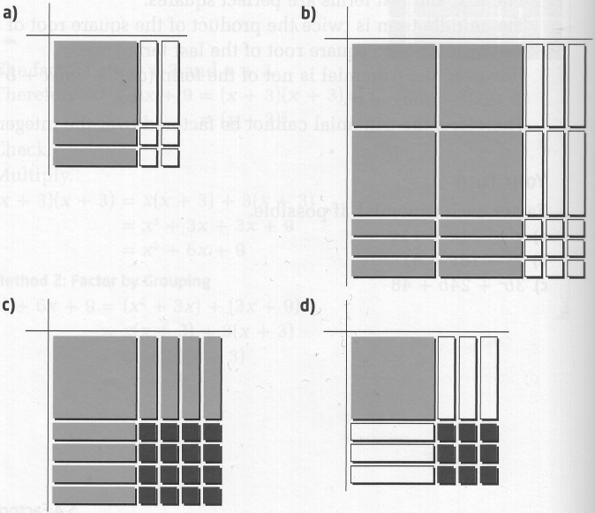

2. Determine each product.

a) (x – 8)(x + 8) b) (2x + 5)(2x – 5)

c) (3a – 2b)(3a + 2b) d) 3(t – 5)(t + 5)

3. What is each product?

a) (x + 3) 2 b) (3b – 5a) 2

c) (2h + 3) 2 d) 5(x – 2y) 2

4. Factor each binomial, if possible.

a) x2 – 16 b) b2 – 121

c) w2 + 169 d) 9a2 – 16b2

e) 36c2 – 49d2 f) h2 + 36f2

g) 121a2 – 124b2 h) 100 – 9t2

5. Factor each trinomial, if possible.

a) x2 + 12x + 36 b) x2 + 10x +25

c) a2 – 24a – 144 d) m2 – 26m + 169

e) 16k2 – 8k + 1 f) 49 – 14m + m2

g) 81u2 + 34u + 4 h) 36a2 + 84a + 49

6. Factor completely.

a) 5t2 – 100 b) 10x3y – 90xy

c) 4x2 – 48x + 36 d) 18x3 + 24x2 + 8x

e) x4–16 f) x4 – 18x2 + 81

7. Each of the following polynomials cannot be factored over the integers. Why not?

a) 25a2 – 16b b) x2 – 7x – 12

c) 4r2 – 12r – 9 d) 49t2 + 100

8. Many number tricks can be explained using factoring. Use a2 – b2 = (a – b)(a + b) to make the following calculations possible using mental math.

a) 192 – 92 b) 282 – 182

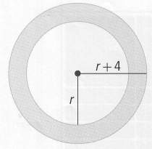c) 352 – 252 d) 52 – 252

9. The diagram shows two concentric circles with radii r and r + 4.

a) Write an expression for the area of the shaded region.

b) Factor this expression completely.

c) If r = 6 cm, calculate the area of the shaded region. Give your answer to the nearest tenth of a square centimetre.

10. State whether the following equations are sometimes, always, or never true. Explain your reasoning.

a) a2 – 2ab – b2 = (a–b)2 b ≠ 0

b) a2 + b2 = (a + b)(a + b)

c) a2 – b2 = a2 – 2ab + b2

d) (a + b) 2 = a2 + 2ab + b2

11. Rahim and Kate are factoring 16x2 + 4y2. Who is correct? Explain your reasoning.

Rahim

16x2 + 4y2 = 4(4x2 + y2)

Kate

16x2 + 4y2 = 4(4x2 + y2)

= 4(2x – y)(2x + y)